Chapter 4, Problem 15.

For the circuit in Fig. 4.83, use superposition to find i. Calculate the power delivered to the 3-Ω resistor.

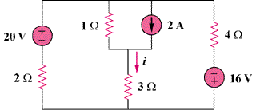

Figure 4.83
For Prob. 4.15.

